**User manual**

The project is hosted on GitHub here: <https://github.com/SamuelSnowball/Major-Project>

To see a quick overview of how the project evolved go to: Major Project/screenshots/evolution of the project.

**Compatibility**

Recommended browser **Firefox**

Please ensure you have the latest version of Firefox and your graphics drivers are up to date.

Supported browsers and operating systems:

* Firefox, Windows 10
* Firefox, MacOSX
* Firefox, Linux
* Chrome, Windows 10

(Firefox in Windows 10 working)

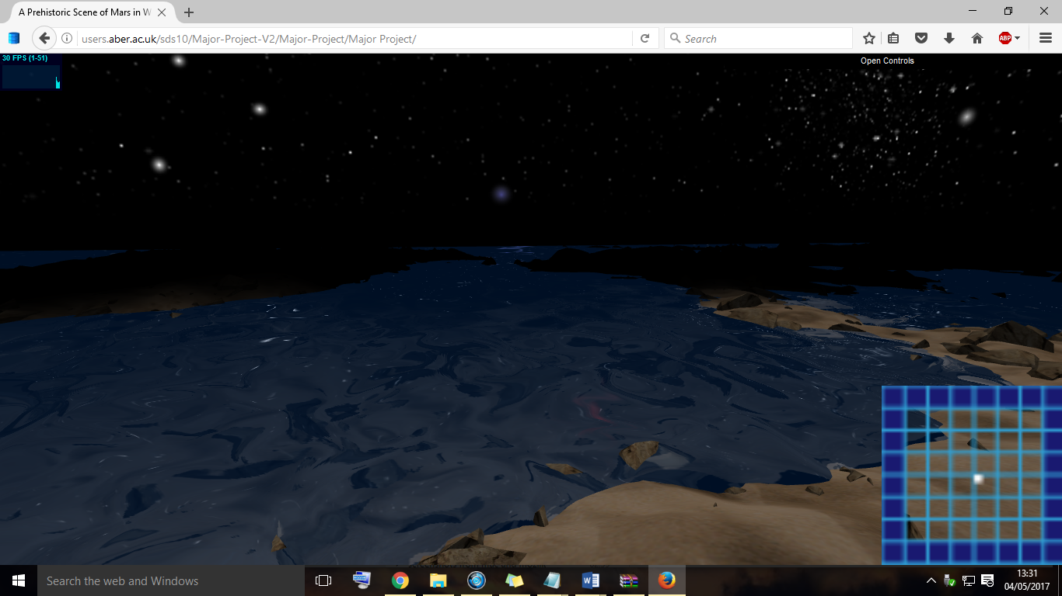

(Firefox in MacOSX working)

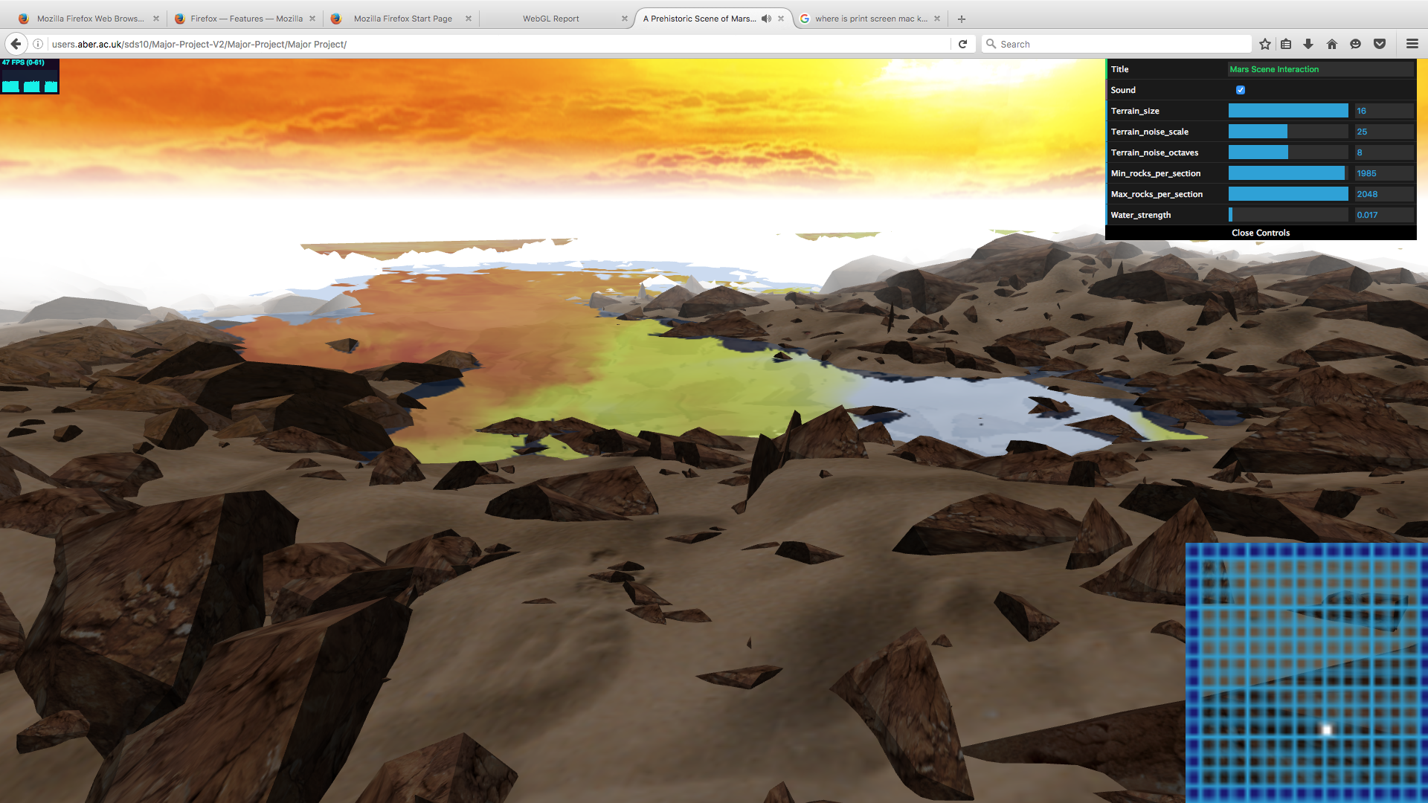

(Firefox in Linux working)

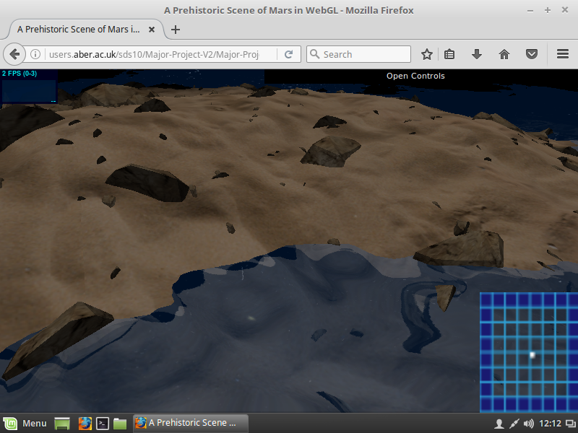

(Chrome in Windows 10 working)

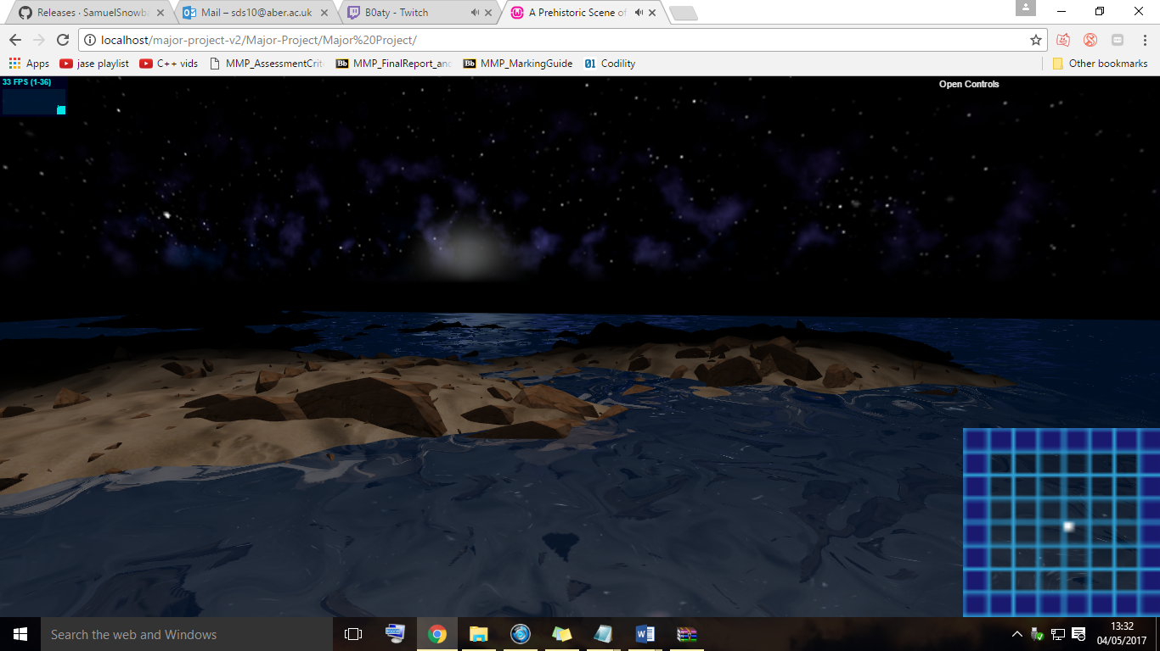

Operating systems/browsers not supported

* Chrome in Linux. The project didn’t run on Chrome on a Linux machine in the Delphinium. It was also tested within a linux mint VM and also didn’t work. This may be due to the hardware OR the browser – the project may or may not be the issue.
* Chrome on MacOSX. Only the rocks render. No terrain or water. Again, this could be an issue with the Orchards Macs hardware and or browser version.

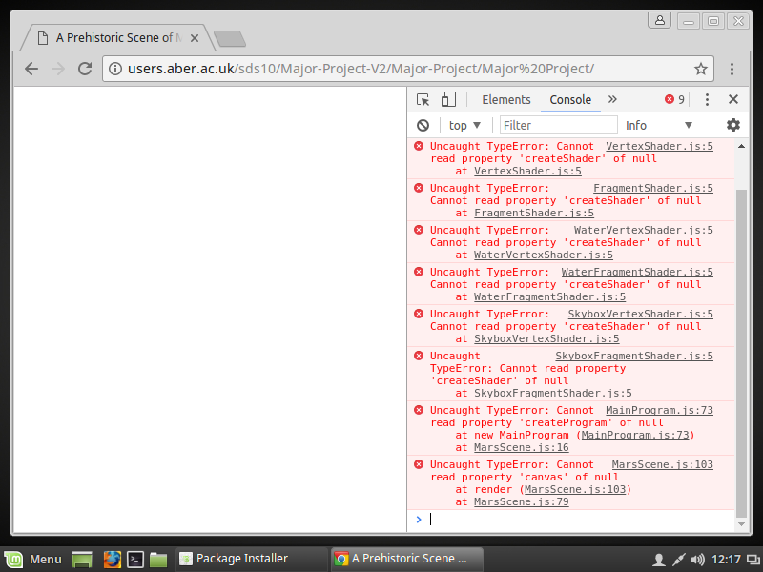(Not working on Chrome in Linux, image below)

(Not working fully on Chrome in MacOSX, image below)

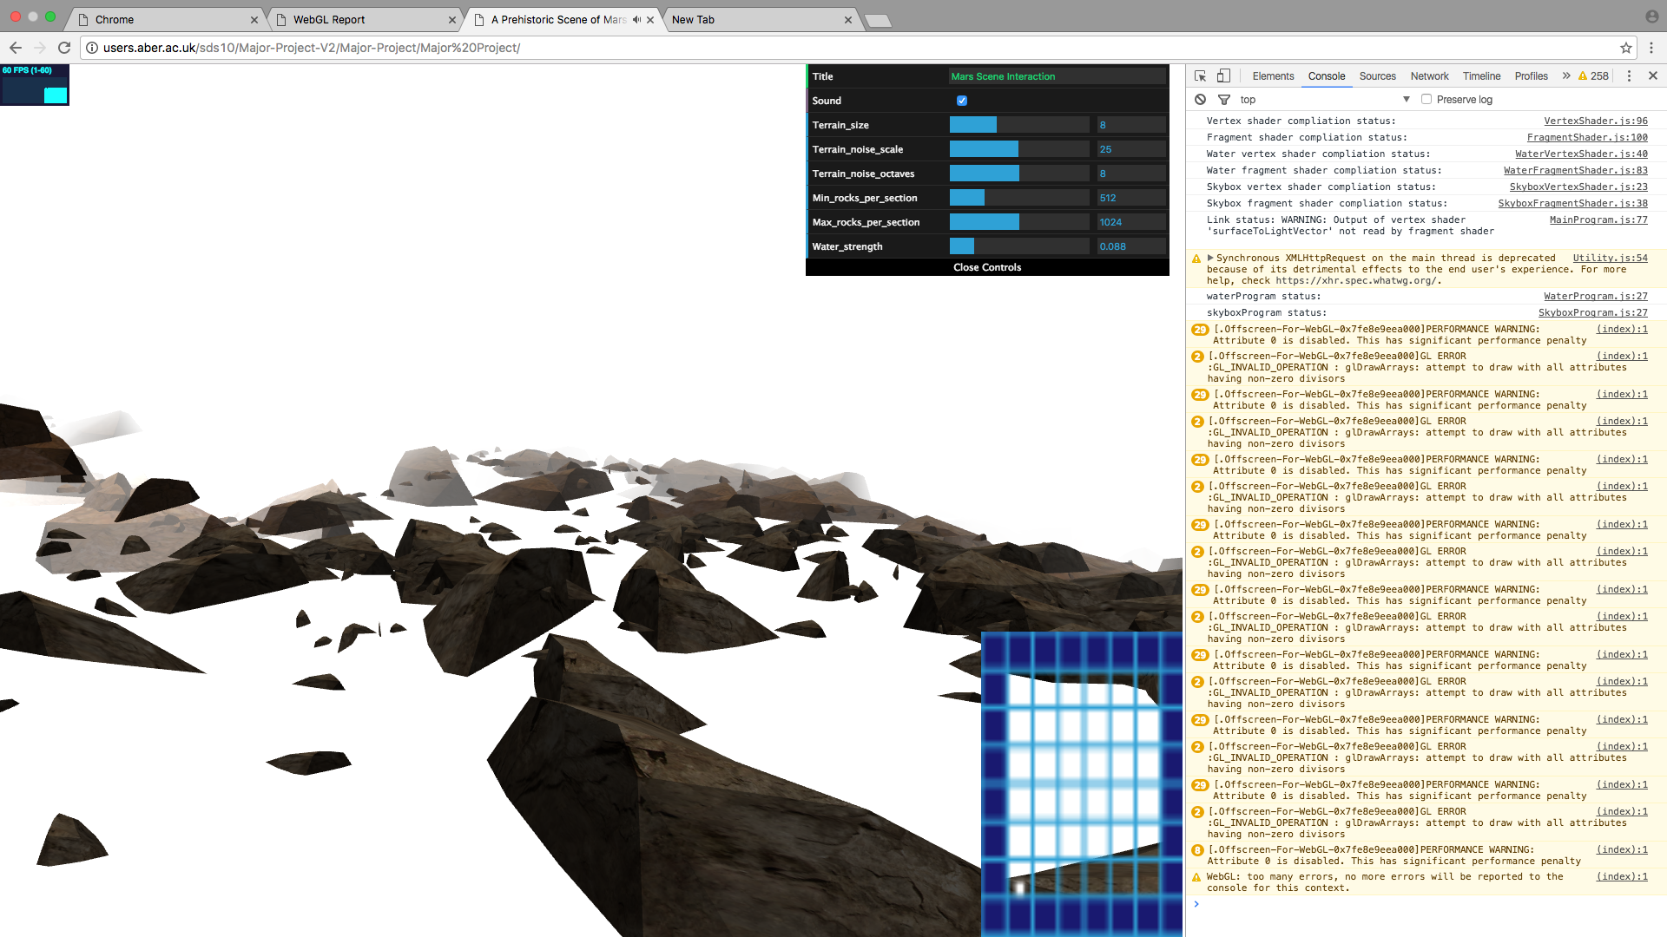

Browsers that aren’t supported at all (they haven’t implemented WebGL properly)

* Safari
* Chromium
* Internet explorer
* Edge

**How to build and run the project**

Please use one of the above browsers (Firefox on any OS, or Chrome in Windows 10) note your browser must support WebGL v1.0 run the project.

Check if your browser supports WebGL (v1.0) : <http://webglreport.com/>

However, the project must also be on one of the above supported browsers.

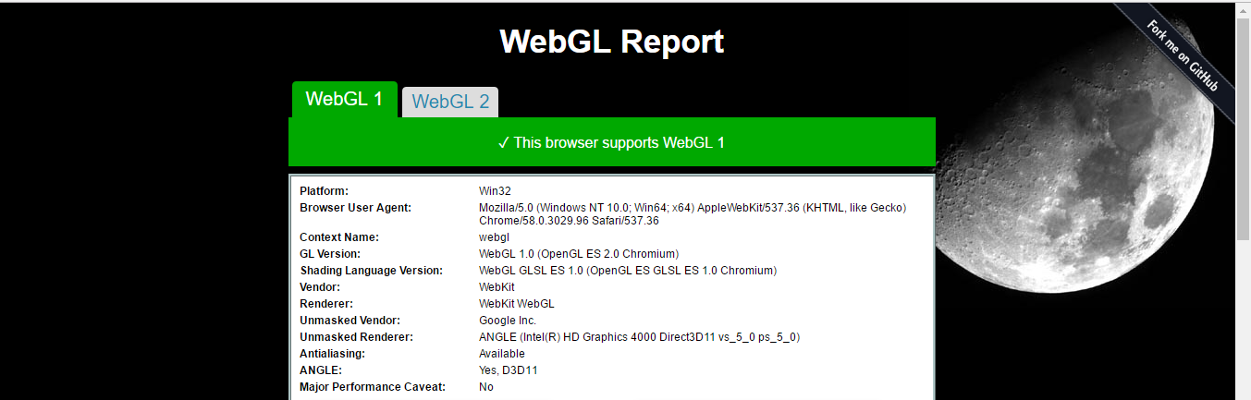

This project needs to be run on a local server. However there is a version already running a local server, this is simply to save building and installing it yourself. It’s located on:

dcs.aber.ac.uk/sds10

(perhaps the file permissions could be looked at to show it wasn’t changed after the hand in date!)

However, the documentation on the server at dcs.aber.ac.uk/sds10 will be a few days out of date – as the software is being hosted there today (4th May). But the documentation will be updated over the next few days. So don’t check the documentation on that server – it’s just there so you don’t have to build a version yourself.

On Windows you can use a WAMP server to host the project:

<https://sourceforge.net/projects/wampserver/>

The apache server will also work:

https://httpd.apache.org/download.cgi

Extract the source files to the www folder of the WAMP server.

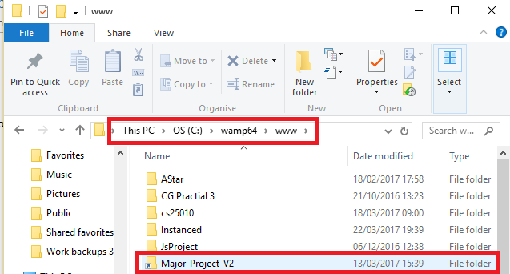

Once hosted, navigate to: localhost/major-project-v2/Major-Project/Major Project/

You may have to do a hard refresh of the localhost for it to update. To do this, hold control and press F5 whilst in a browser.

**Controls**

Once opened, click on the window to lock the pointer. If you wish to change the scene properties, press escape, change the properties and then click back on the scene afterwards to re-lock the pointer.

To look around, use the mouse whilst the pointer is locked.

To move around, use the following keys:

* W (forward)
* S (backward)
* R (rise)
* F (fall)

To move left/right, you can just look to the left/right then move forward.

**Scene interaction**

The user has the ability to change:

* Sound on/off
* Terrain size
* Terrain noise scale
* Terrain noise octaves
* Min rocks per section (Note, this must be less than the max per section!)
* Max rocks per section
* Water strength